**DECIMAL TO BINARY CONVERSION:**

**EXP NO:25**

**AIM:**To write a C program to implement decimal to binary conversion.

**APPARATUS:** DEV C++

**PROCEDURE:**

1) Check if your number is odd or even.  
2) If it's even, write 0 (proceeding backward, adding binary digits to the left of the result).   
3)   Otherwise, if it's odd, write 1 (in the same way).  
4)   Divide your number by 2 (dropping any fraction) and go back to step 1. Repeat until your original number is 0.

**PROGRAM:**

#include<stdio.h>     
#include<stdlib.h>   
int  
main()  
{   
int a[10],n,i;     
printf("Enter the number to convert: ");     
scanf("%d",&n);     
for(i=0;n>0;i++)     
{     
a[i]=n%2;     
n=n/2;     
}     
printf("\nBinary of Given Number is=");     
for(i=i-1;i>=0;i--)     
{     
printf("%d",a[i]);     
}     
return 0;  
}

**INPUT:**

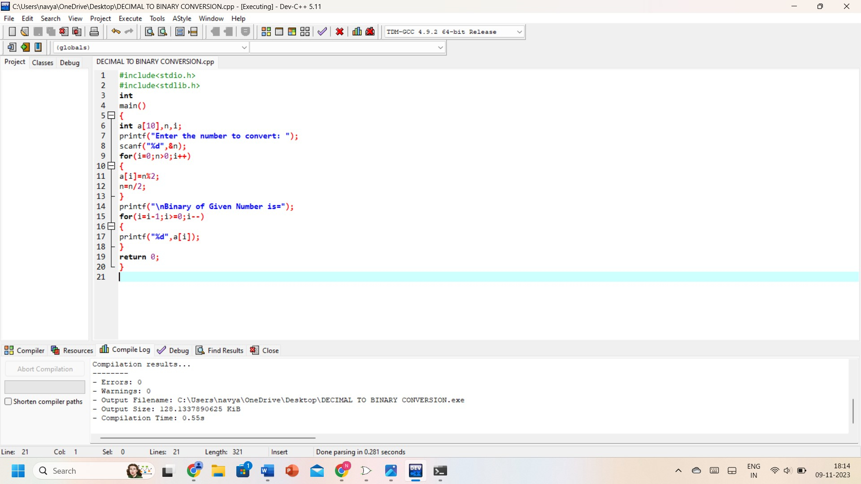

**OUTPUT:**

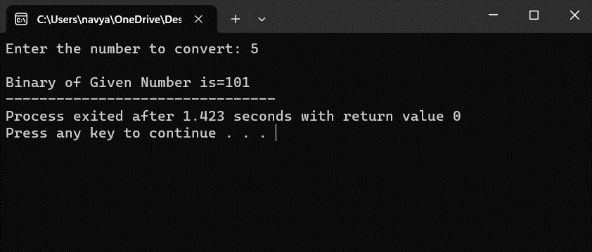

**RESULT:** Thus the program was executed successfully using DevC++.